Exercice :[mathssa.fr/classification](http://www.mathssa.fr/classification)

Quel est le plus petit ensemble de nombres auquel appartient chacun des nombres suivants ?

1) 2) 3) 4) 5) 6)

Méthode : Reconnaître la nature d’un nombre

[mathssa.fr/classification](http://www.mathssa.fr/classification)

Quel est le plus petit ensemble de nombres auquel appartient chacun des nombres suivants ?

1) 2) 3) 4) 5) 6)

**Correction**

1) $-$ $\frac{1}{4}$ $=-0,25$

Donc $-$ $\frac{1}{4}$ $∈$ ⅅ car le nombre de décimales après la virgule est en nombre fini.

2) $\frac{2}{6}$ $=$ $\frac{1}{3}$ $≈0,3333…$

Donc $\frac{2}{6}∈Q$ car $\frac{2}{6}$ s’écrit uniquement sous forme d’une fraction et ne peut pas s’écrire sous forme décimale.

3) ⅅ car le nombre de décimales après la virgule est en nombre fini.

4) $\sqrt{36}=6$

Donc $\sqrt{36}∈$ ℕ car $6$ est un nombre entier positif.

5) $\sqrt{6}≈2,4495…$

Donc $\sqrt{6}$ $∈$ ℝ car c’est un nombre irrationnel.

$$6) \frac{-3{\left(\sqrt{2}\right)}^{2}}{12}=\frac{-3×2}{12}=\frac{-6}{12}=-0,5$$

Donc $\frac{-3{\left(\sqrt{2}\right)}^{2}}{12}$ $∈$ ⅅ car le nombre de décimales après la virgule est en nombre fini.

**Exercice sur les ensembles de nombres:**

Mettre une croix lorsque le nombre appartient à l’ensemble indiqué

1.

|  |  |  |  |  |  |  |  |  |  |  |  |  |
| --- | --- | --- | --- | --- | --- | --- | --- | --- | --- | --- | --- | --- |
|  | 0,777 | $$\frac{7}{25}$$ | $$3-\sqrt{36}$$ | $$\frac{1}{6}$$ | $$\frac{π}{4}$$ | $${10}^{-4}$$ | -14,6 | $$\frac{197}{2}$$ | $${10}^{10}$$ | 3,14159 | $$\sqrt{π²}$$ | $$\frac{\sqrt{25}}{\sqrt{9}}$$ |
| ∈ℕ |  |  |  |  |  |  |  |  |  |  |  |  |
| ∈ℤ |  |  |  |  |  |  |  |  |  |  |  |  |
| ∈D |  |  |  |  |  |  |  |  |  |  |  |  |
| ∈ℚ |  |  |  |  |  |  |  |  |  |  |  |  |
| ∈ℝ |  |  |  |  |  |  |  |  |  |  |  |  |

2.

|  |  |  |  |  |  |  |  |  |  |  |  |  |  |
| --- | --- | --- | --- | --- | --- | --- | --- | --- | --- | --- | --- | --- | --- |
|  |  | -10 | 10 | 4,555... | -1,44 |  |  |  | $$\frac{-60\sqrt{2}}{\sqrt{8}}$$ | 51022,66 | 4110 | + |  |
| ∈ℕ |  |  |  |  |  |  |  |  |  |  |  |  |  |
| ∈ℤ |  |  |  |  |  |  |  |  |  |  |  |  |  |
| ∈D |  |  |  |  |  |  |  |  |  |  |  |  |  |
| ∈ℚ |  |  |  |  |  |  |  |  |  |  |  |  |  |
| ∈ℝ |  |  |  |  |  |  |  |  |  |  |  |  |  |

3.

|  |  |  |  |  |  |  |  |  |  |  |  |  |  |  |  |
| --- | --- | --- | --- | --- | --- | --- | --- | --- | --- | --- | --- | --- | --- | --- | --- |
|  | 0 |  |  | - 104 |  | -675,94 |  | 10-9 | 4- | -x |  |  |  | - |  |
| ∈ℕ |  |  |  |  |  |  |  |  |  |  |  |  |  |  |  |
| ∈ℤ |  |  |  |  |  |  |  |  |  |  |  |  |  |  |  |
| ∈D |  |  |  |  |  |  |  |  |  |  |  |  |  |  |  |
| ∈ℚ |  |  |  |  |  |  |  |  |  |  |  |  |  |  |  |
| ∈ℝ |  |  |  |  |  |  |  |  |  |  |  |  |  |  |  |

|  |  |  |  |  |  |  |  |  |  |  |  |  |  |  |  |  |  |
| --- | --- | --- | --- | --- | --- | --- | --- | --- | --- | --- | --- | --- | --- | --- | --- | --- | --- |
|  |  | 3,5 | 4,0 | $$-7$$ | $$\frac{7}{3}$$ | $$\frac{12}{3}$$ | $$\frac{1}{2}$$ | 3,1 | $$\sqrt{2}$$ | - $\frac{1}{2}$ | $$\frac{-84}{14}$$ | $$\frac{-7}{20}$$ | $$\frac{81}{4}$$ | $$\sqrt{\frac{81}{4}}$$ | 10 | 2,3535… | 0,123514527  89… |
| ∈ℕ |  |  |  |  |  |  |  |  |  |  |  |  |  |  |  |  |  |
| ∈ℤ |  |  |  |  |  |  |  |  |  |  |  |  |  |  |  |  |  |
| ∈D |  |  |  |  |  |  |  |  |  |  |  |  |  |  |  |  |  |
| ∈ℚ |  |  |  |  |  |  |  |  |  |  |  |  |  |  |  |  |  |
| ∈ℝ |  |  |  |  |  |  |  |  |  |  |  |  |  |  |  |  |  |

**Correction des exercices sur les ensembles de nombres:**

1.

|  |  |  |  |  |  |  |  |  |  |  |  |  |
| --- | --- | --- | --- | --- | --- | --- | --- | --- | --- | --- | --- | --- |
|  | 0,777 | $$\frac{7}{25}=$$ $$0,28$$ | $$3-\sqrt{36}$$ $$=3-6=-3$$ | $$\frac{1}{6}$$ | $$\frac{π}{4}$$ | $${10}^{-4}$$ =0,0001 | -14,6 | $$\frac{197}{2}$$ $=$ 98,5 | $${10}^{10}$$ =10000000000 | 3,14159 | ==π  car π>0 | $$\frac{\sqrt{25}}{\sqrt{9}}=\frac{5}{3}$$ |
| ∈ℕ |  |  |  |  |  |  |  |  | * |  |  |  |
| ∈ℤ |  |  | * |  |  |  |  |  | * |  |  |  |
| ∈D | * | * | * |  |  | * | * | * | * | * |  |  |
| ∈ℚ | * | * | * | * |  | * | * | * | * | * |  | * |
| ∈ℝ | * | * | * | * | * | * | * | * | * | * | * | * |

2.

|  |  |  |  |  |  |  |  |  |  |  |  |  |  |
| --- | --- | --- | --- | --- | --- | --- | --- | --- | --- | --- | --- | --- | --- |
|  | =10 | -10 | 10 | 4,555... | -1,44 |  |  |  |  | 51022,66 | 4110 | + |  |
| ∈ℕ | * |  |  |  |  |  |  |  |  |  |  |  | * |
| ∈ℤ | * | * |  |  |  | * |  |  | * |  |  |  | * |
| ∈D | * | * | * |  | * | * | * |  | * | * | * | * | * |
| ∈ℚ | * | * | * | * | * | * | * |  | * | * | * | * | * |
| ∈ℝ | * | * | * | * | * | * | * | * | * | * | * | * | * |

3.

|  |  |  |  |  |  |  |  |  |  |  |  |  |  |  |  |
| --- | --- | --- | --- | --- | --- | --- | --- | --- | --- | --- | --- | --- | --- | --- | --- |
|  | 0 |  |  | - 104 |  | -675,94 |  | 10-9 | 4- | -x |  |  |  | - |  |
| ∈ℕ | * |  |  |  |  |  |  |  |  |  |  |  |  |  |  |
| ∈ℤ | * |  |  | * |  |  |  |  | * | * |  |  |  | * |  |
| ∈D | * | * | * | * |  | * |  | * | * | * |  |  | * | * |  |
| ∈ℚ | * | * | * | * | * | * |  | * | * | * |  | * | * | * | * |
| ∈ℝ | * | * | * | * | * | * | * | * | * | * | * | * | * | * | * |

**Correction des exercices 133,134,135,136,137,138,139,140,141,142p70-71**

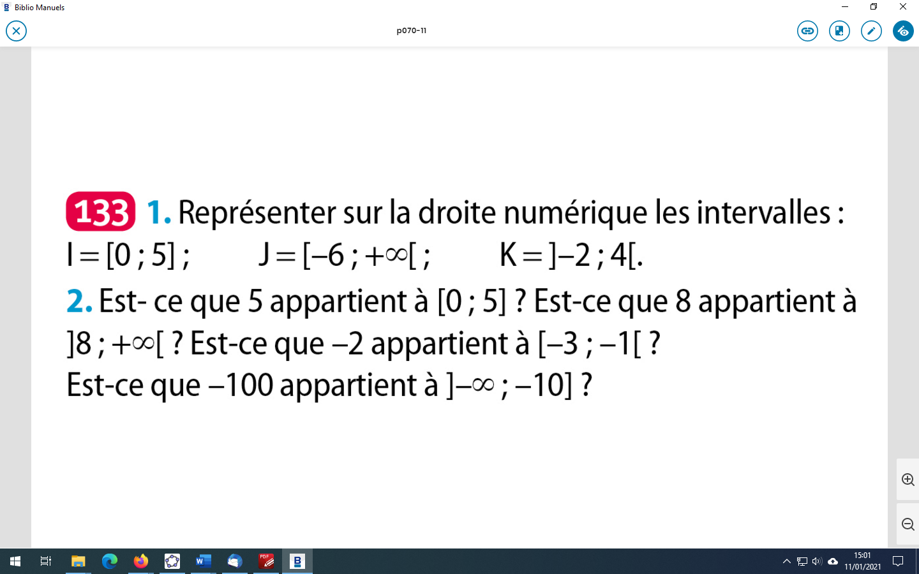

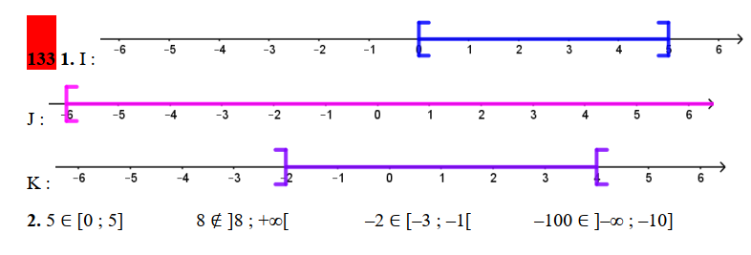

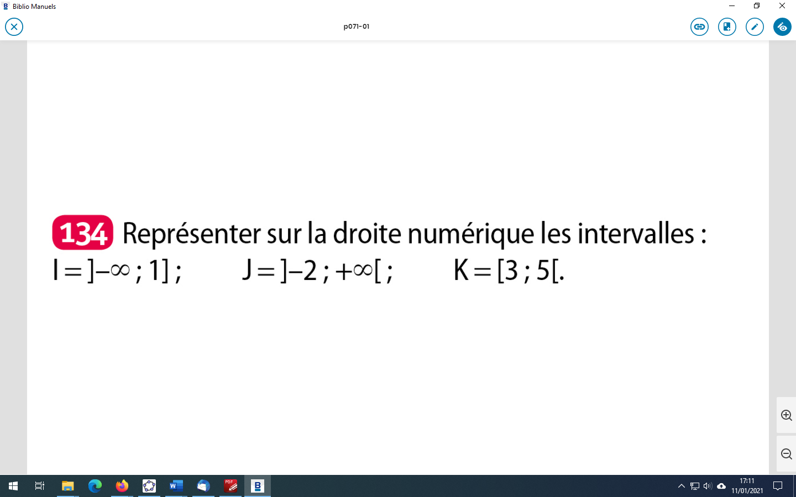

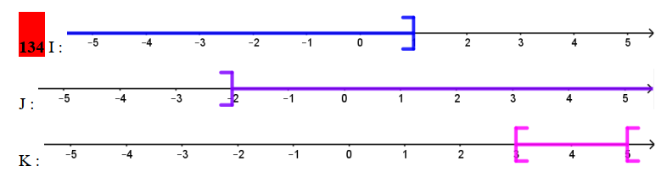

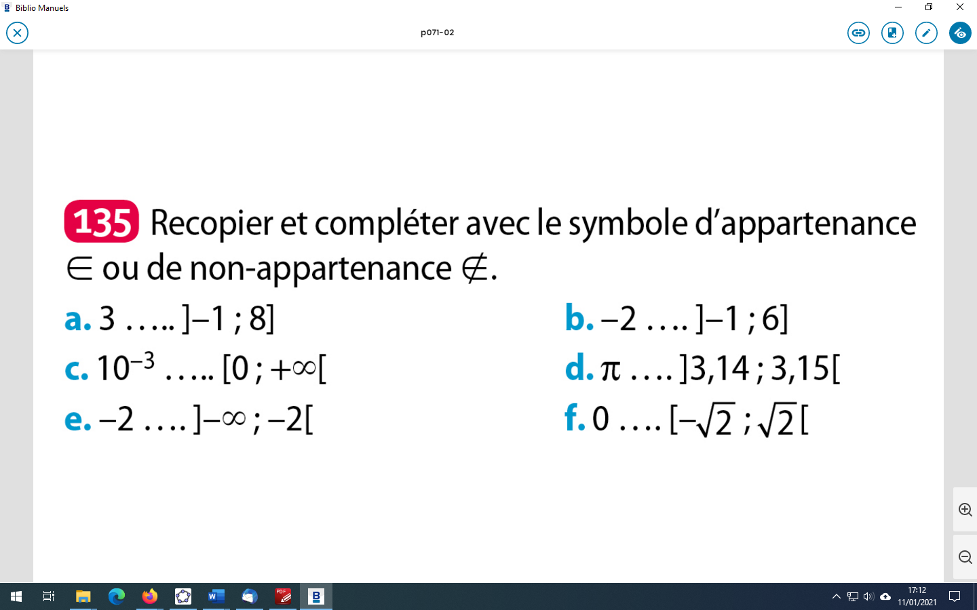

∉

∉

∈

∈

∈

∈

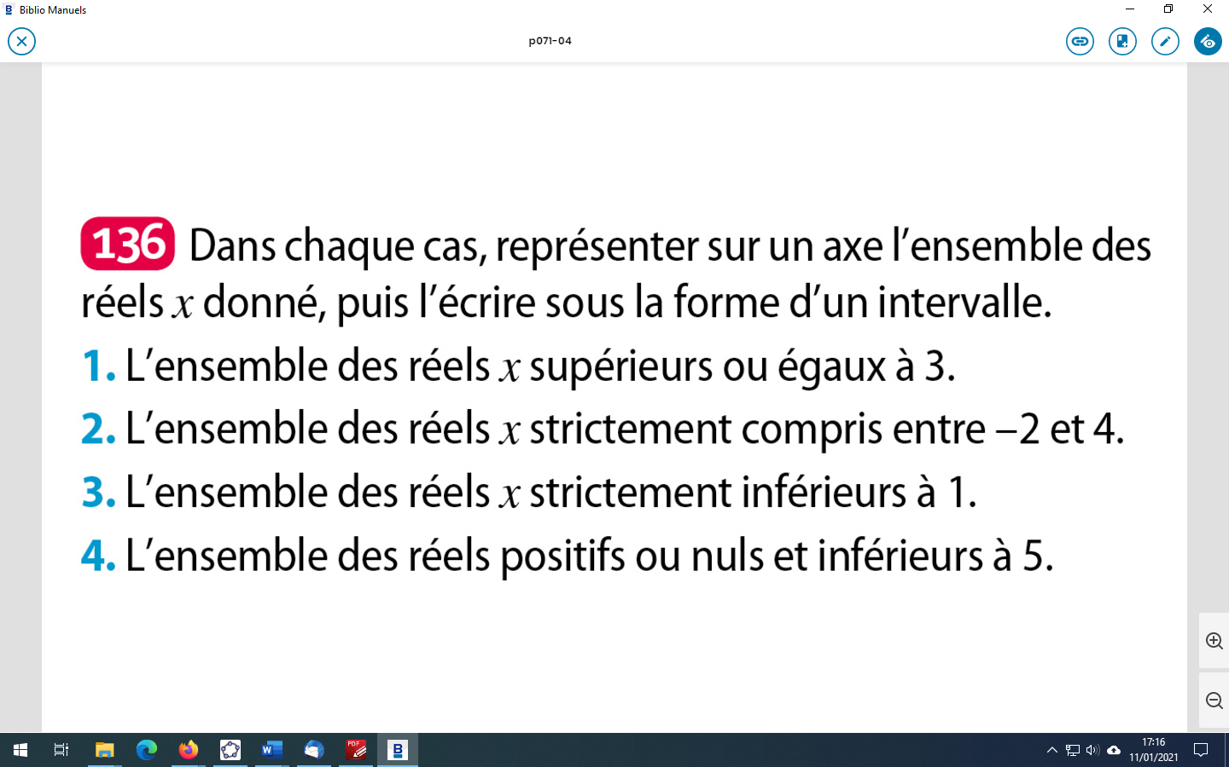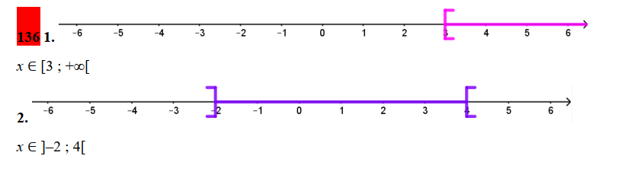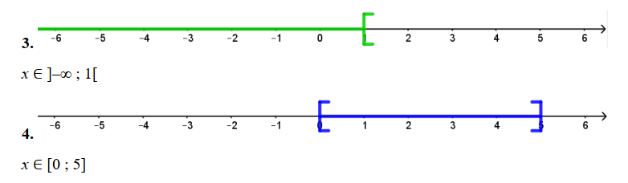

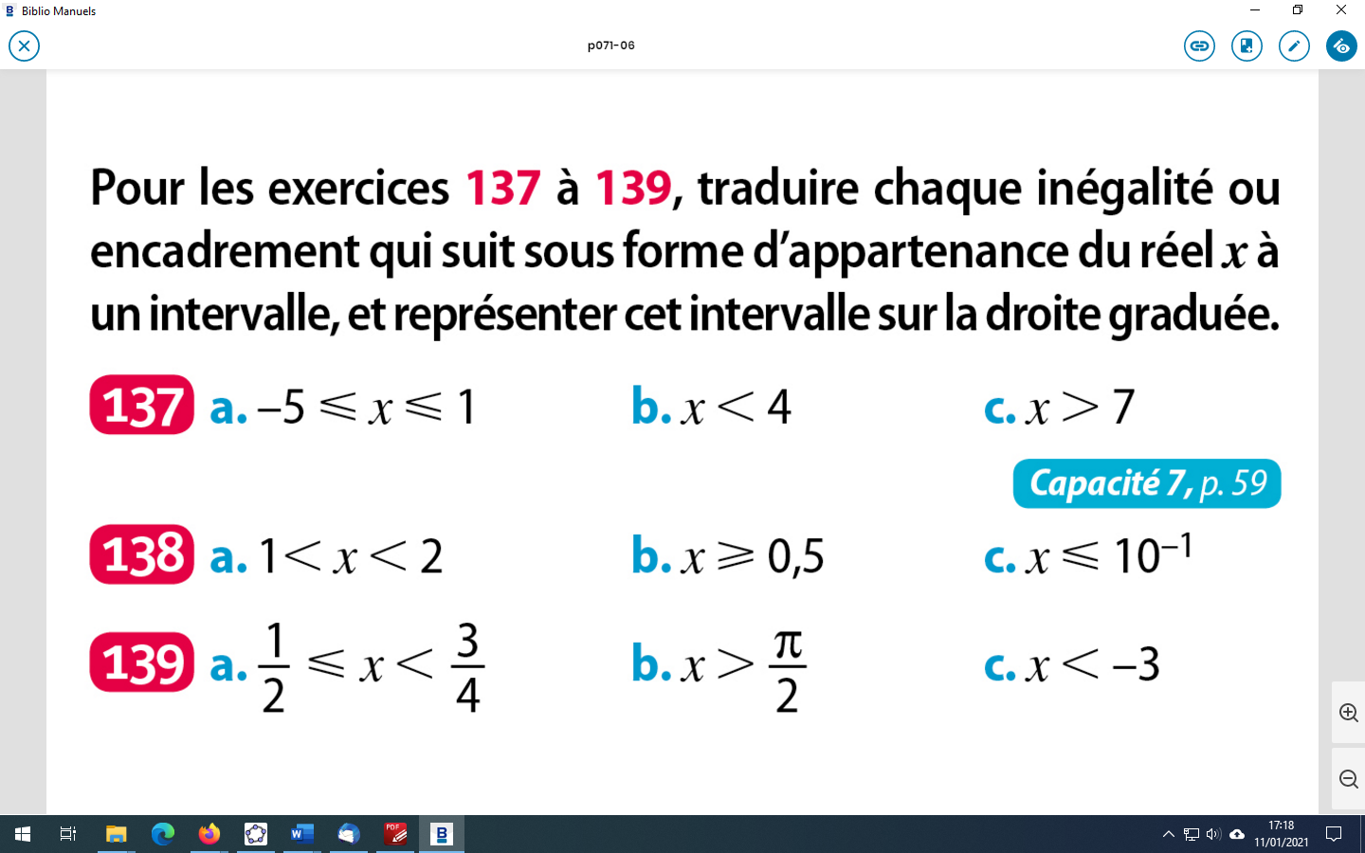

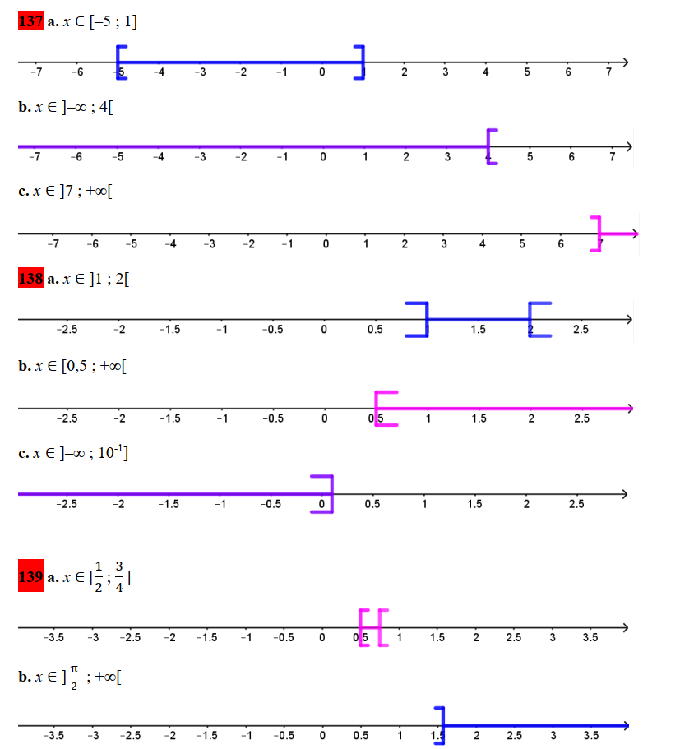

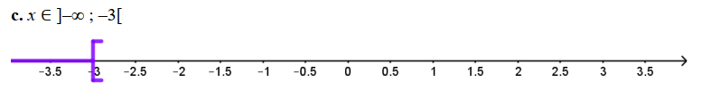

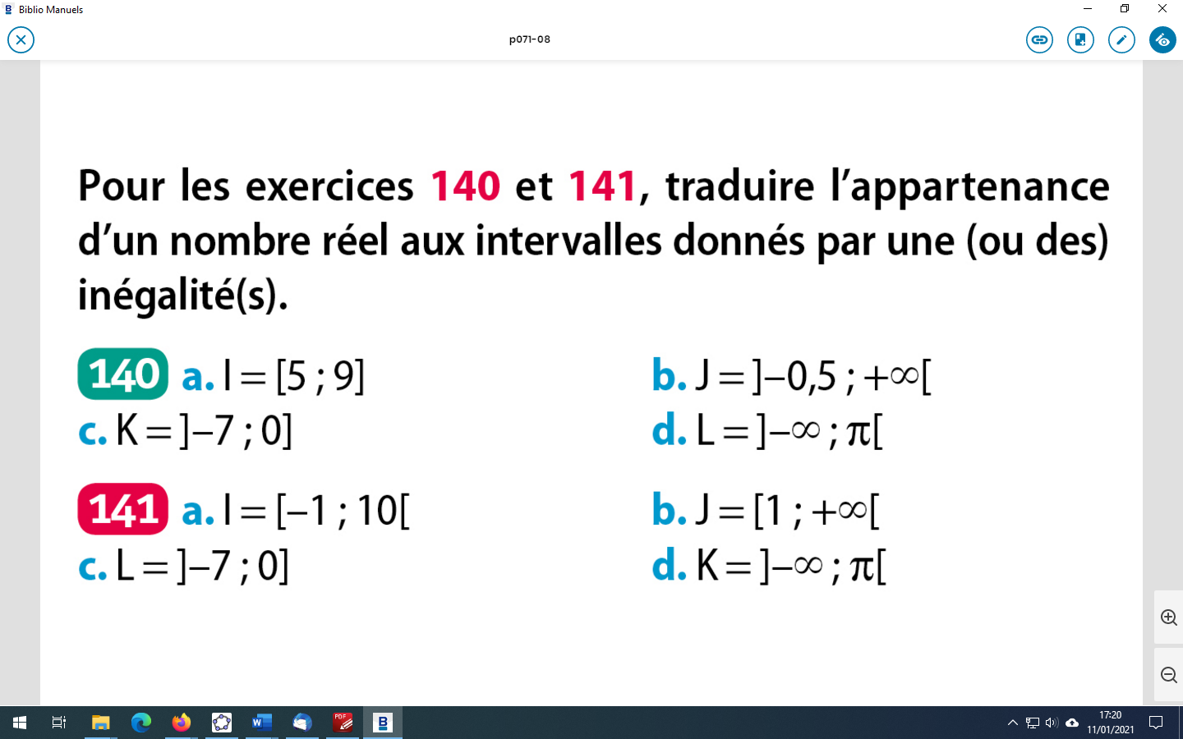

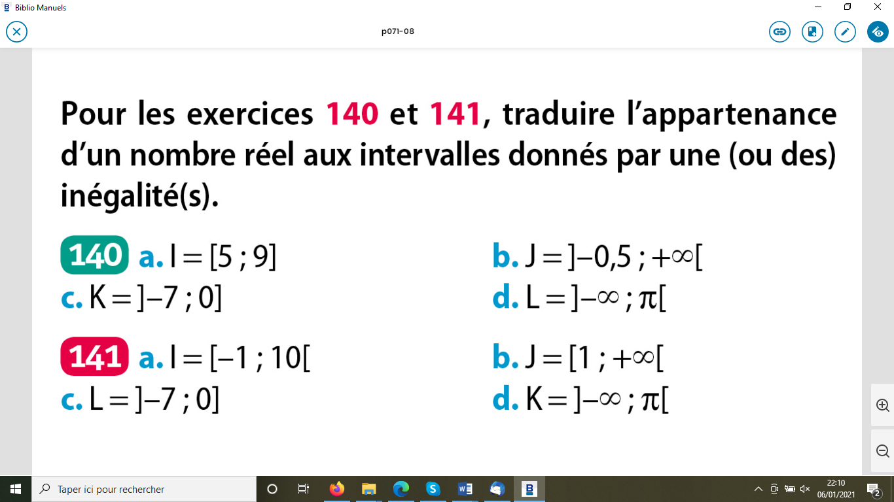

a) $x∈[-1;10[$ équivaut à $-1≤x<10$.

b) $x∈[1;+∞[$ équivaut à $x≥1$.

c) $x∈]-7;0]$ équivaut à $-7<x≤0$.

d) $x∈]-∞;π[$ équivaut à $x<π$.

