**Correction des exercices partie E**

**Exercice 1 : comprendre la fonction range**

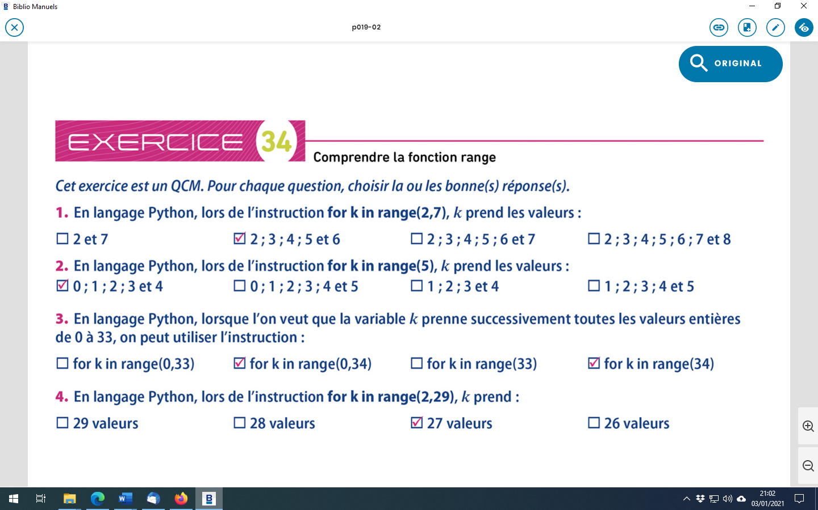

**Exercice 2 : comprendre la fonction range**

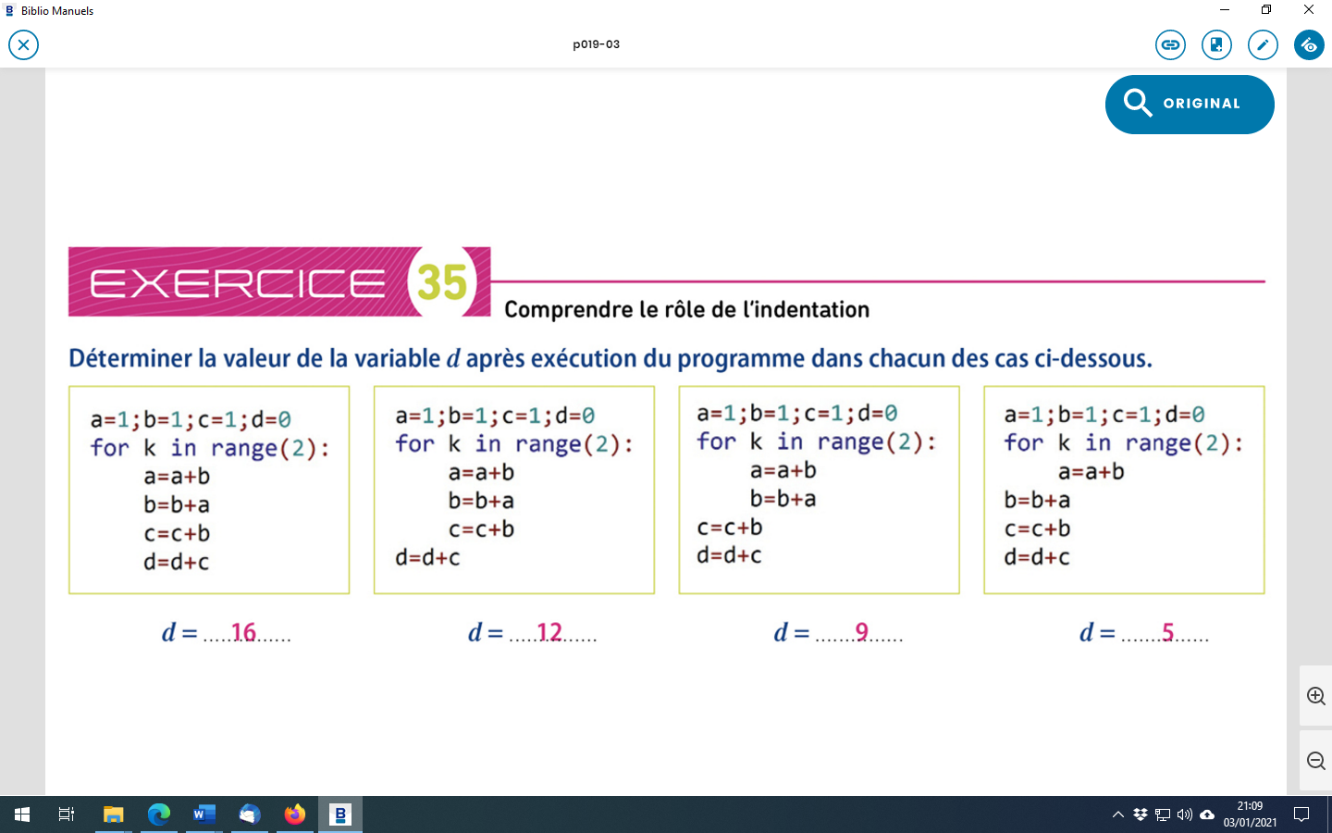

|  |  |  |  |  |  |  |  |  |  |  |  |  |  |  |  |  |  |  |  |  |  |  |  |  |  |  |  |  |  |  |  |  |  |  |  |  |  |  |  |  |  |  |  |  |  |  |  |  |  |  |  |  |  |  |  |  |  |  |  |  |  |  |  |  |  |  |  |  |  |  |  |  |
| --- | --- | --- | --- | --- | --- | --- | --- | --- | --- | --- | --- | --- | --- | --- | --- | --- | --- | --- | --- | --- | --- | --- | --- | --- | --- | --- | --- | --- | --- | --- | --- | --- | --- | --- | --- | --- | --- | --- | --- | --- | --- | --- | --- | --- | --- | --- | --- | --- | --- | --- | --- | --- | --- | --- | --- | --- | --- | --- | --- | --- | --- | --- | --- | --- | --- | --- | --- | --- | --- | --- | --- | --- |
| |  |  |  |  |  | | --- | --- | --- | --- | --- | | a | b | c | d | k | | 1 | 1 | 1 | 0 |  | | 2 | 3 | 4 | 4 | 0 | | 5 | 8 | 12 | 16 | 1 | | |  |  |  |  |  | | --- | --- | --- | --- | --- | | a | b | c | d | k | | 1 | 1 | 1 | 0 |  | | 2 | 3 | 4 | 0 | 1 | | 5 | 8 | 12 | 0 | 2 | | 5 | 8 | 12 | 12 | 2 | | |  |  |  |  |  | | --- | --- | --- | --- | --- | | a | b | c | d | k | | 1 | 1 | 1 | 0 |  | | 2 | 3 | 1 | 0 | 0 | | 5 | 8 | 1 | 0 | 1 | | 5 | 8 | 9 | 9 | 1 | |

**Exercice 3 : comprendre un programme**

|  |  |  |  |  |  |
| --- | --- | --- | --- | --- | --- |
| A | « Je dis : » | « Je dis : bravo » | « Je dis : bravo bravo» | « Je dis : bravo bravo bravo» | « Je dis : bravo bravo bravo bravo» |
| i |  | 1 | 2 | 3 | 4 |

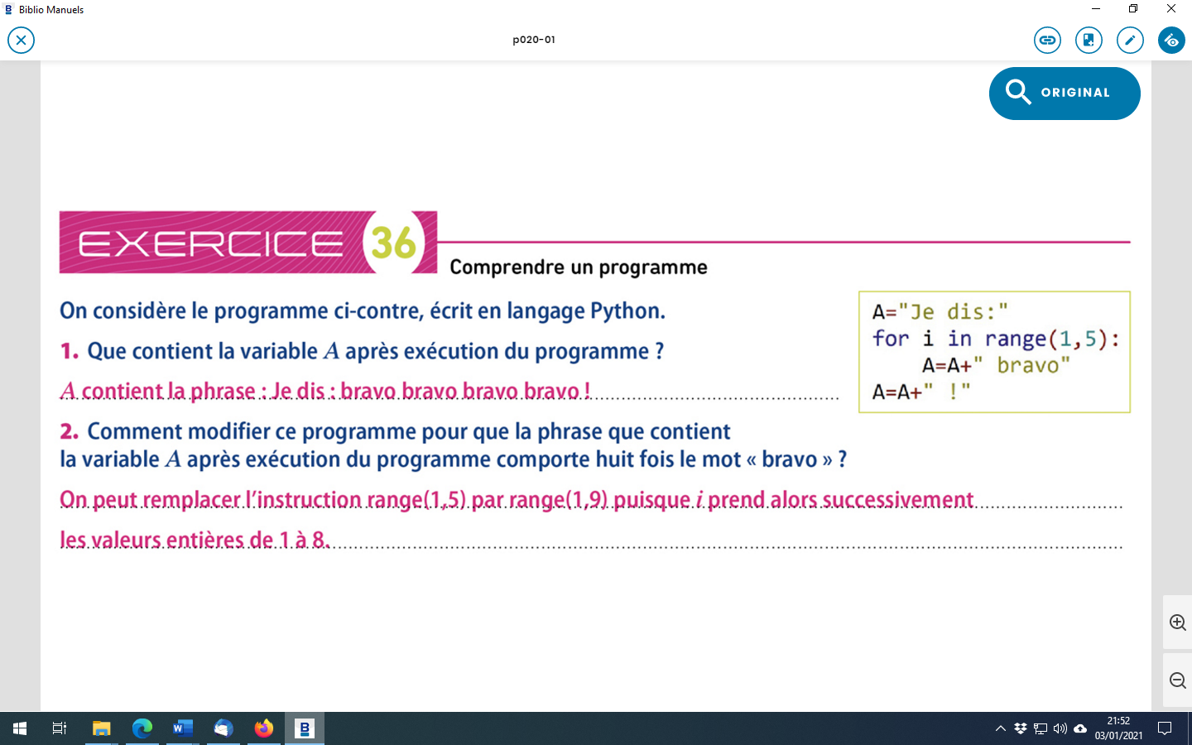

**Exercice 4 : lancers de dé- compléter un programme**

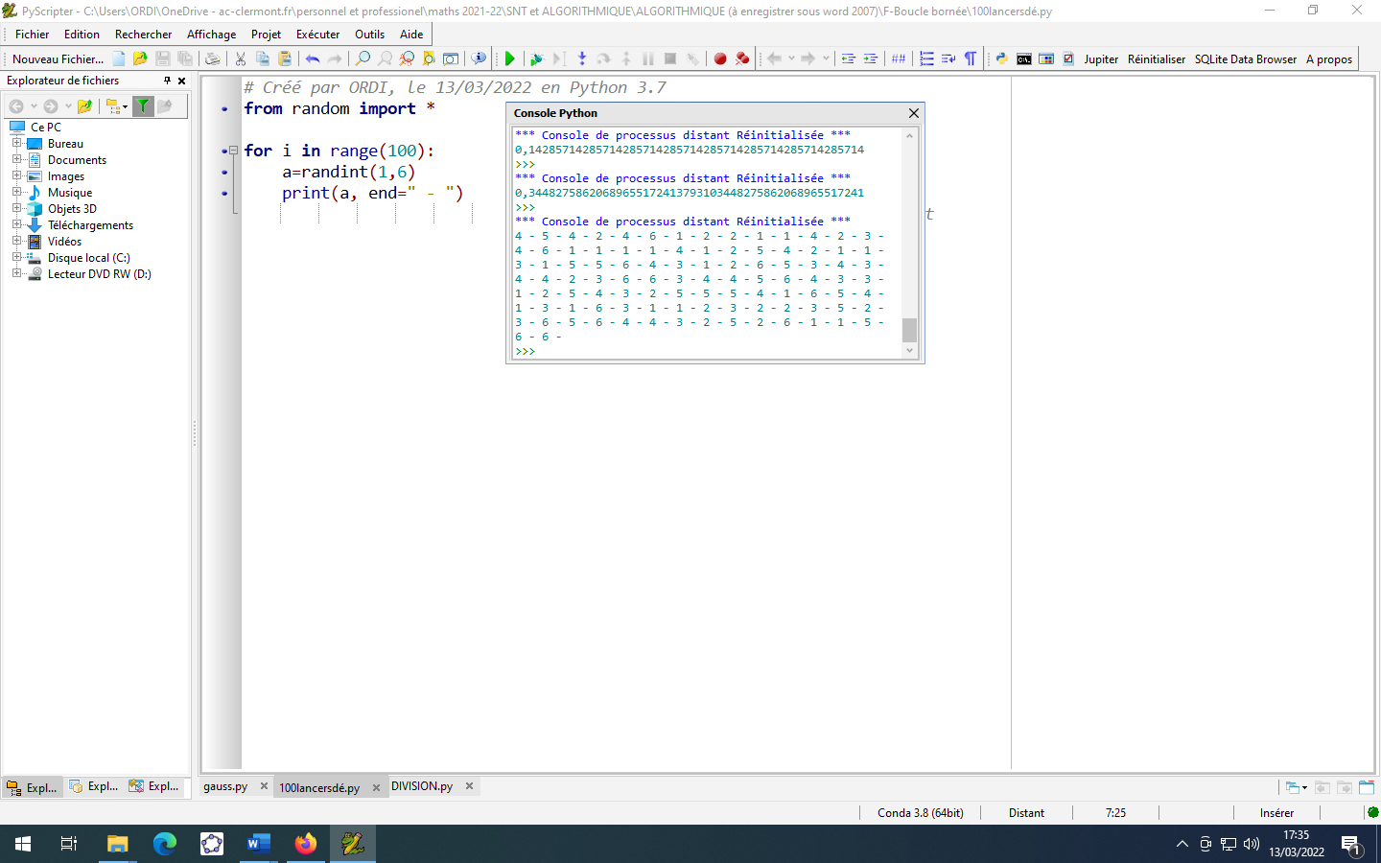

**Exercice 5 : somme de Gauss – compléter un programme**

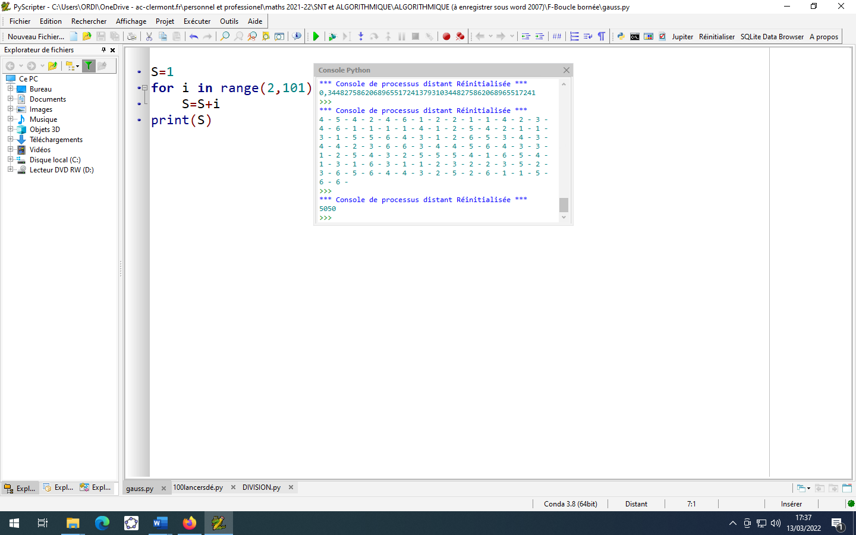

S=5 050

**Méthode de Gauss :**

S =1 + 2 + 3 + … + 98 + 99 + 100

S =100 + 99 + 98 + … + 3 +2 + 1 (on écrit la somme à l’envers)

2S=101 +101 +101 + … + 101+101+101 (on ajoute membre à membre)

2S=

S=

**Exercice 6 : capital placé- compléter un programme**

On place un capital de 10 000 euros à un taux d’intérêt annuel de 6%

1.Donner sans justifier le montant du capital au bout de un an.

€

2. 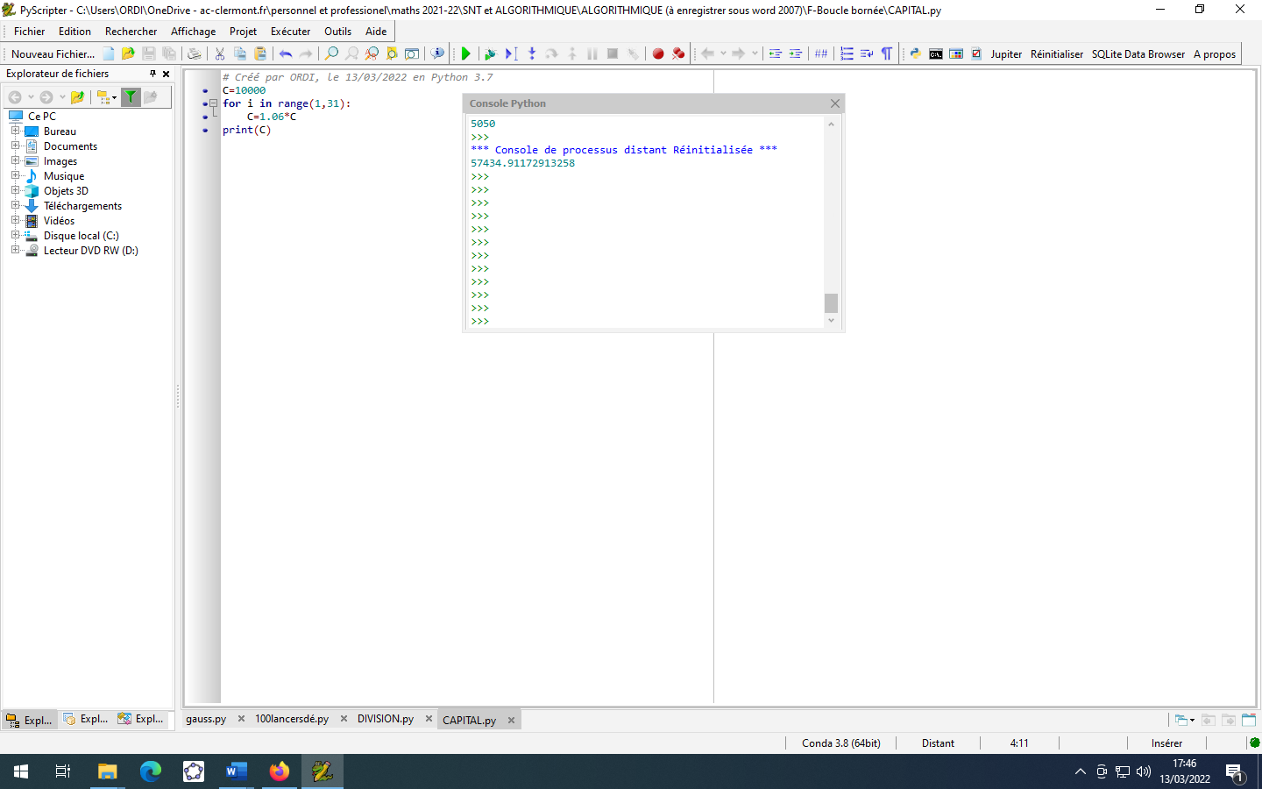

**Exercice 7 : écrire les 50 premières décimales d’un nombre rationnel**

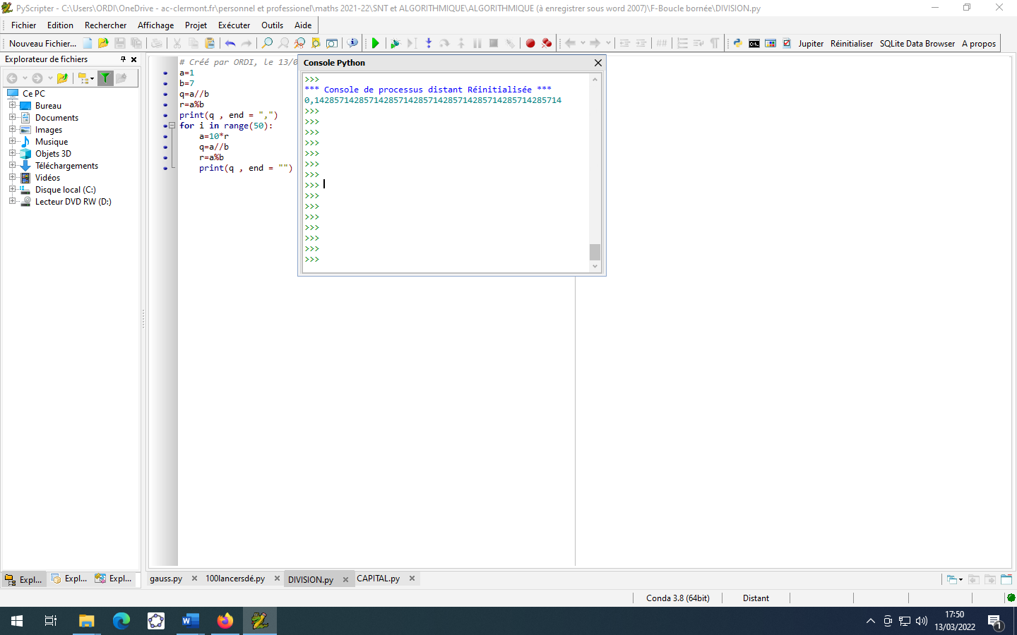

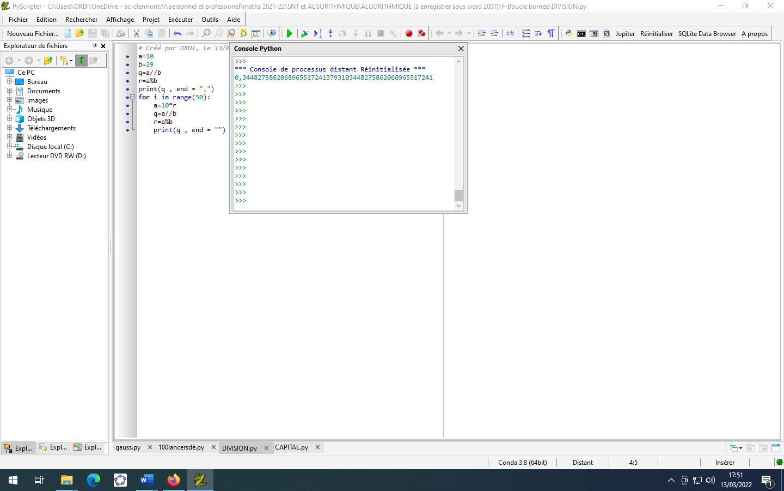

**Exercice 8 : comprendre et compléter un programme**

